Renewable energy is the need of the hour. With more houses and businesses, adopting the wind, solar energy harvests. The fundamental challenges of a modern grids also raises, the mismatch between the solar energy generated and when people actually use the power. Solar energy generation usually peaks midday and demands peaks during evengings. This generates the “Duck Cuve” phenomena.

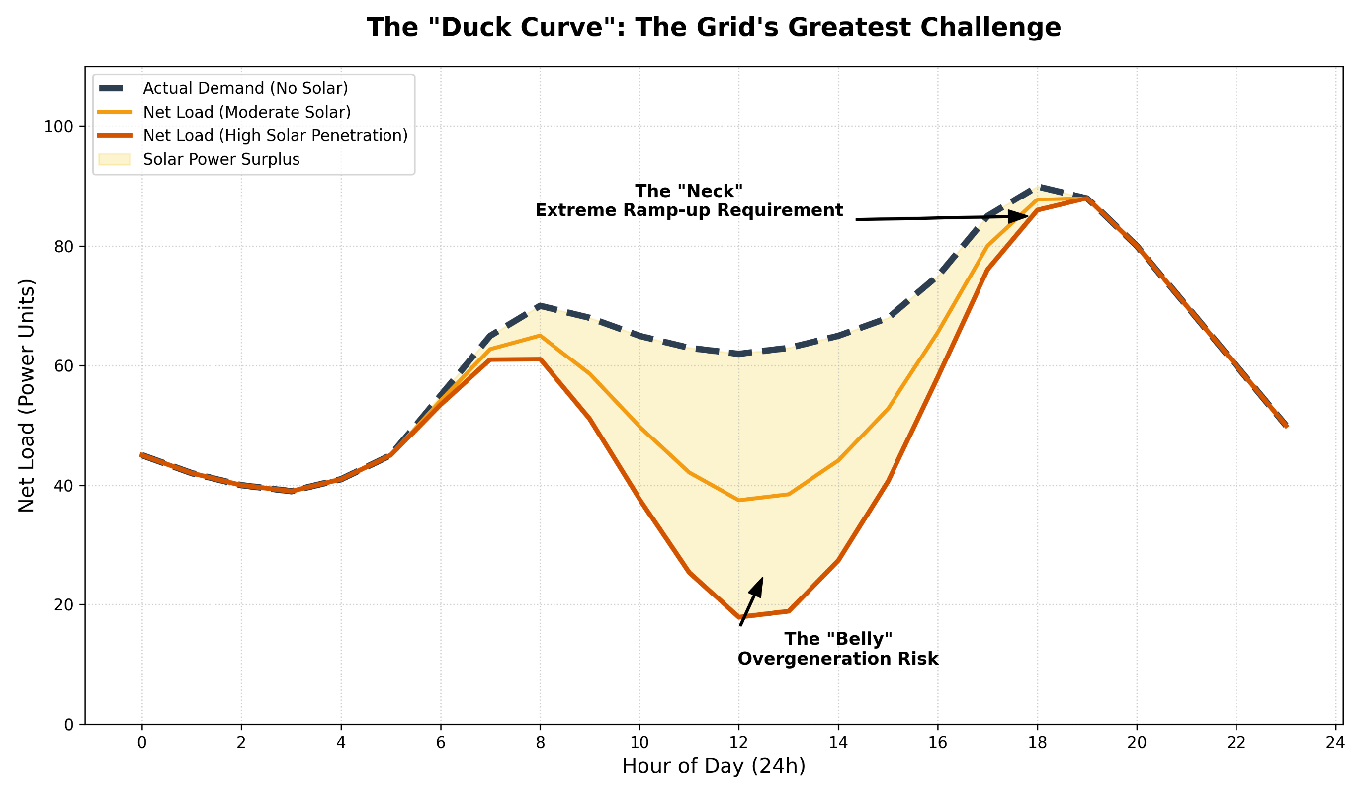

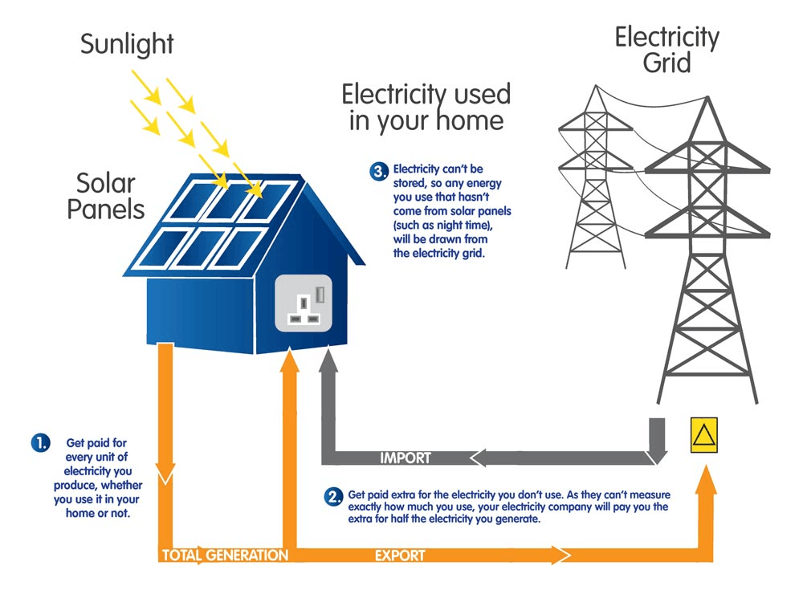

The macros level problem is made worse at the neighbourhood level, when usually users are concerned about their own needs. The grid has to ensure that power outrages don’t occur, This uncoordinated behavior creates massive, localized power peaks that can overload the local transformer, leading to instability and potential blackouts. This is the specific problem your project addresses.

To address the critical challenge, a virtual power plan is developed using Distributed optimizations. This system doesn't control the agents directly but uses a "Shadow Price Signal" to coordinate their behavior. The Aggregator calculates a price signal that reflects the overall needs of the grid. It sends this signal to the agents. Each player ndependently adjusts their behavior based on this signal to maximize their own benefit. The result is a coordinated, harmonious system where the local grid is balanced and stable, transforming potential chaos into a valuable grid asset.

We have a each user, trying to maximise profit (explain how profit is generated)
The user also considers the risks involved by considering CvaR.
The aggregator ensures, that the grid level operations are stable. This coordination problem is addressed by looking at all agents and coming up with necessary adjustments..

Result
The system reached a precision of 10−6 within 100 iterations. The final dispatch profiles show the
School absorbing the Baker’s midday solar surplus, while the Family provides evening discharge
to offset peak demand. The neighborhood as a whole appears to the grid as a perfectly balanced,
zero-impact asset.

